Tem-pi-rature Recorder

Dr Duncan Rowland – University of Lincoln, U.K.

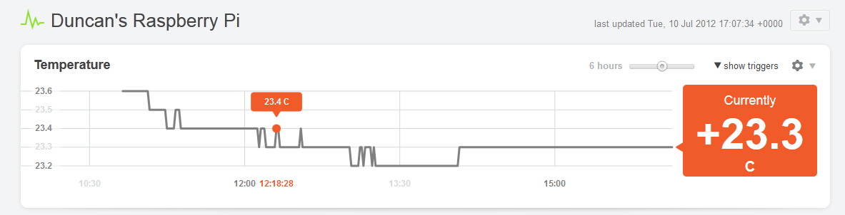

This article builds on topics from previous issues of The MagPi and shows how to add a temperature sensor to your Pi together with a simple method to record and display the data on the web.

The temperature sensor used is the ‘tmp102’ and this connects via the i2c bus and (http://www.ti.com/product/tmp102). The sensor readily available already mounted on a breakout board (http://www.sparkfun.com/products/9418) so with the addition of some header pins it can be pushed straight onto a breadboard for prototyping (see photos). The 2012-07-15-wheezy-raspbian release already has the i2c modules included and the firmware is ready to go too ☺

The instructions that follow do not require the graphical user interface, so you can boot your Pi and use a keyboard or remotely login via ssh as you prefer.

First we need to install the tools for talking to the i2c bus

sudo apt-get update
sudo apt-get install i2c-tools

There are a couple of modules we need to add (i2c-bcm2708 and i2c-dev). You can either include then manually by issuing the following ‘modprobe’ commands (in which case you will need to do this each time you reboot); or you can add them to the file ‘/etc/modules’ (in which case they will be loaded automatically when you reboot):

sudo modprobe i2c-bcm2708
sudo modprobe i2c-dev

Finally, so that you can read from the i2c bus, you need to add the pi user to the i2c user group (after which you will need to logout and log back in for the change to take effect).

sudo usermod –a –G i2c pi
logout

If you have correctly connected your tmp102 sensor (as shown in the photos) it should now be accessible to you on the i2c bus when you log back in.

Wiring Connections:

GND → P1-06 = Ground
SCL → P1- 05 = I2C0_SCL
SDA → P1-03 = I2C0_SDA
V+ → P1-01 = 3V3 Power
ALT → leave disconnected
ADD0 → Ground

Now you should be able to communicate with the device.
i2cget -y 0 0x48 0x00 w

This will read the value in address (0x48) on i2c bus (0) which is the current value of the sensor. The datasheet referenced above shows how to convert this hexadecimal value into degrees centigrade, and the following awk script performs this task.

awk '{print(("0x"substr($1,5,2)substr($1,3,1))*0.0625)}'

Essentially what this does is to reorder the bits (using sub-strings) and appropriately scale the resulting value for degrees. It can be combined with the first command using a pipe ‘|’ which takes the result of i2cget and sends it to awk. i.e.

i2cget -y 0 0x48 0x00 w | \
awk '{print(("0x"substr($1,5,2)substr($1,3,1))*0.0625)}'

The following wraps this in a bash script so it can be run from the command line (with a slight adjustment to the output to force two decimal places and a newline). Make a new file called tmp102.sh and add the following:
#!/bin/bash
i2cget -y 0 0x48 0x00 w | \
awk '{printf("%.2f\n", \
("0x"substr($1,5,2)substr($1,3,1))*0.0625)}'
To make the script executable you need to type

chmod +x tmp102.sh

and you can run it by typing

./tmp102.sh

One fun thing to do with this data is to send it to the “Internet of Things” web service COSM. This will store your data and plot graphs that can be embedded in a web page. We can automatically run the process every minute or so and send the value to COSM. First you will need to login and create an account on http://cosm.com. Once you’re verified (via email) you can make a new “Device” (aka “Feed”). Click on the word “Adding” and then “Something Else” to create a feed for your Pi. Select “No, I will push data to COSM” and fill out the rest of the configuration as you’d like (a good title would be something like “My Raspberry Pi”. You will receive a “feed ID” which you will need to send updates. In the “update.sh” script below you should put this value where I have left XXXXX.

Next we need to define a “Datastream” for this feed. In the console click on “+ Datastream” and enter the required data (e.g. ID = Temperature; Symbol = °C). The ID you specify will need to be provided when you send updates. In the blank.json data template below, you should put this where I have the entry YYYYY.
Finally, we need a key that gives us permission to post updates to the COSM server. Go to the Keys section (situated in the top-right corner in a drop-down menu next to your name) and click “+ Key”. Choose a label and leave the Feed Restrictions as the default “Use any public feed” and Access Privileges can be set to all. The key that is generated is a long string of characters and this is required to authenticate updates. In the “update.sh” script below you should put this value where I have left ZZZZZ.

The COSM server expects data in a specific format. Save the following in a file called “blank.json” (remembering to replace the value YYYYY with your datastreams ID).
{
"version":"1.0.0",
"datastreams":[
{"id":"YYYYY", "current_value":"T1"}
]
}

You can now create a new update.sh script file as below incorporating the values for your device ID (XXXXX) and your authentication key (ZZZZZ). The script is essentially the same as our previous efforts, with a couple of additions. First, the template data file “blank.json” is sent to the “sed” command which replaces the “T1” with the temperature value from the sensor. Second, “curl” is used to send the newly created data-file (send.json) to the COSM server. You will need to make the script executable as before (chmod +x update.sh) and run it (./update.sh). All things being well your Pi should be sending regular updates to your COSM data feed, you can ask COSM to plot this on as an embeddable graph by clicking the cog and selecting “Graph Builder”.
#!/bin/bash
while true;
do
temp=$(./tmp102.sh)
cat blank.json | sed 's/T1/'$temp'/g' > send.json
curl --request PUT \
--data-binary @send.json \
--header "X-ApiKey: ZZZZZ" \
http://api.cosm.com/v2/feeds/XXXXX
sleep 60
done

You can stop the update.sh script by pressing Ctrl+C. If you would like to leave the script running in the background after you have logged out, then you can run the script like this instead

nohup ./update.sh > /dev/null &

and when you log back in, stop it by typing

killall update.sh

Thumbnails below: full resolution images at: http://socuso.com/cut.zip

